**Coronavirus Tweet Sentiment Analysis**

**Sandeep R**

**Data science trainee,**

**AlmaBetter, Bangalore**

**Abstract:**

This project addresses the problem of Coronavirus sentiment analysis in twitter; that is classifying tweets according to the sentiment expressed in them: positive, negative or neutral. Twitter is an online micro-blogging and social-networking platform which allows users to write short status updates of maximum length 140 characters. It is a rapidly expanding service with over 200 million registered users [24] - out of which 100 million are active users and half of them log on twitter on a daily basis - generating nearly 250 million tweets per day [20]. Due to this large amount of usage we hope to achieve a reflection of public sentiment by analyzing the sentiments expressed in the tweets. Analyzing the public sentiment is important for many applications such as firms trying to find out the response of their products in the market, predicting political elections and predicting socioeconomic phenomena like stock exchange. The aim of this project is to develop a functional classifier for accurate and automatic sentiment classification of an unknown tweet stream.

**1. Problem Statement**

The Dataset contains tweets of various sentiments which includes [Neutral, Positive, Negative, Extremely Positive and Extremely Negative]. The task is to build a model which predicts the sentiment of given tweet. Therefore we need to train a model with the given dataset which can predict the sentiment of the tweet.

Independent Variables:

* Original Tweet : Which includes the tokenized word of the tweet

Dependent Variables:

* Sentiment: This Feature indicates the sentiment of the corresponding tweet.

**2. Introduction**

I have chosen to work with twitter since we feel it is a better approximation of public sentiment as opposed to conventional internet articles and web blogs. The reason is that the amount of relevant data is much larger for twitter, as compared to traditional blogging sites. Moreover the response on twitter is more prompt and also more general (since the number of users who tweet is substantially more than those who write web blogs on a daily basis). Sentiment analysis of public is highly critical in macro-scale socioeconomic phenomena like predicting the stock market rate of a particular firm. This could be done by analyzing overall public sentiment towards that firm with respect to time and using economics tools for finding the correlation between public sentiment and the firm’s stock market value. Firms can also estimate how well their product is responding in the market, which areas of the market is it having a favorable response and in which a negative response (since twitter allows us to download stream of geo-tagged tweets for particular locations. If firms can get this information they can analyze the reasons behind geographically differentiated response, and so they can market their product in a more optimized manner by looking for appropriate solutions like creating suitable market segments. Predicting the results of popular political elections and polls is also an emerging application to sentiment analysis. One such study was conducted by Tumasjan et al. in Germany for predicting the outcome of federal elections in which concluded that twitter is a good reflection of offline sentiment

**3. Cleaning Dataset:**

Sample of Tweet in dataset has to be cleaned

Tweets in the samples contains special characters and apart from the tweet it also contains username, location and URL’s which has to be removed hence I made use of regular expression to remove all the unwanted characters which doesn’t add any value to the tweet sentiment. But most of the data are used to Perform EDA to find the corresponding relation to the Sentiment of the Dataset.

**4. Tweet Sentiment Counts:**

I made use of Matplotlib and SNS library to plot the graphical representation of the count of the sentiments in the given set of samples which can be seen in the below figure.

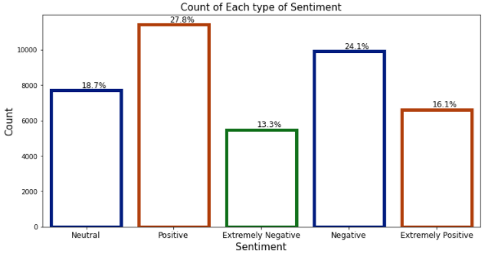

**5. Steps involved:**

* **Exploratory Data Analysis**

After loading the dataset we performed this method by comparing our target variable with other independent variables. This process helped us figuring out various aspects and relationships among the target and the independent variables. It gave us a better idea of which feature behaves in which manner compared to the target variable.

* **Null values Treatment**

Our dataset contains a large number of null values which might tend to disturb our accuracy hence we dropped them at the beginning of our project in order to get a better result.

* **Encoding of categorical columns**

We used One Hot Encoding to produce binary integers of 0 and 1 to encode our categorical features because categorical features that are in string format cannot be understood by the machine and needs to be converted to numerical format.

* **Standardization of features**

Our main motive through this step was to scale our data into a uniform format that would allow us to utilize the data in a better way while performing fitting and applying different algorithms to it.

The basic goal was to enforce a level of consistency or uniformity to certain practices or operations within the selected environment.

* **Fitting different models**

For modelling we tried various classification algorithms like:

1. **Logistic Regression**
2. **SVM Classifier**
3. **Random Forest Classifier**
4. **XGBoost classifier**

* **Tuning the hyperparameters for better accuracy**

Tuning the hyperparameters of respective algorithms is necessary for getting better accuracy and to avoid overfitting in case of tree based models

like Random Forest Classifier and XGBoost classifier.

* **SHAP Values for features**

We have applied SHAP value plots on the Random Forest model to determine the features that were most important while model building and the features that didn’t put much weight on the performance of our model.

**6.1. Algorithms:**

1. **Logistic Regression:**

Logistic Regression is actually a classification algorithm that was given the name regression due to the fact that the mathematical formulation is very similar to linear regression.

The function used in Logistic Regression is sigmoid function or the logistic function given by:

f(x)= 1/1+e ^(-x)

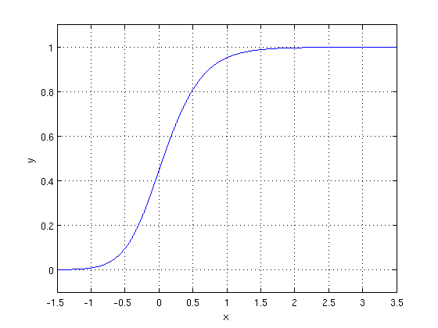

The optimization algorithm used is: Maximum Log Likelihood. We mostly take log likelihood in Logistic:

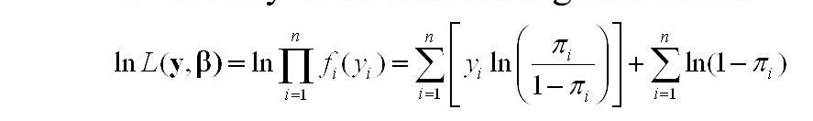

.

1. **Support Vector Machine Classifier:**

SVM is used mostly when the data cannot be linearly separated by logistic regression and the data has noise. This can be done by separating the data with a hyperplane at a higher order dimension.

In SVM we use the optimization algorithm as:

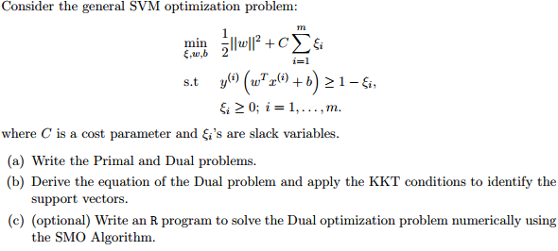

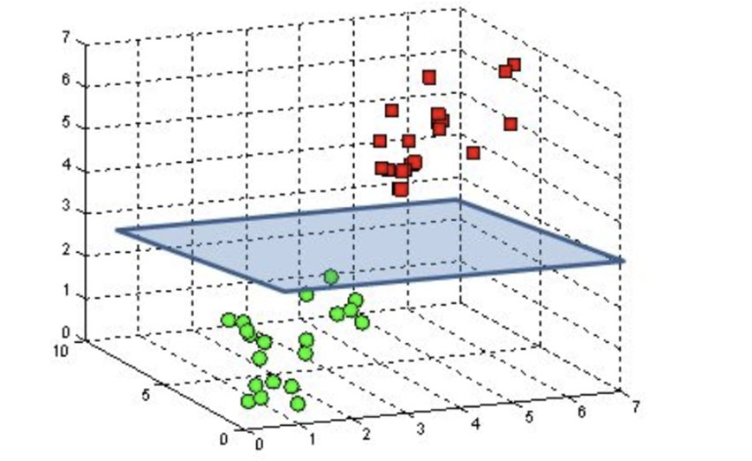

We use hinge loss to deal with the noise when the data isn’t linearly separable.

Kernel functions can be used to map data to higher dimensions when there is inherent non linearity.

1. **Random Forest Classifier:**

Random Forest is a bagging type of Decision Tree Algorithm that creates a number of decision trees from a randomly selected subset of the training set, collects the labels from these subsets and then averages the final prediction depending on the most number of times a label has been predicted out of all.

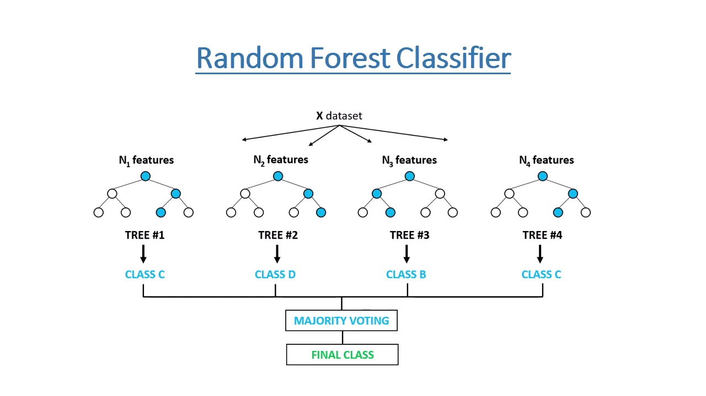

1. **XGBoost-**

To understand XGBoost we have to know gradient boosting beforehand.

* **Gradient Boosting-**

Gradient boosted trees consider the special case where the simple model is a decision tree

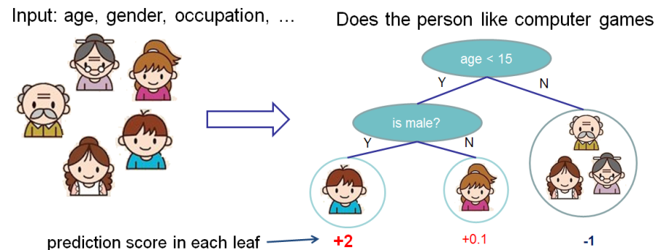

In this case, there are going to be 2 kinds of parameters P: the weights at each leaf, w, and the number of leaves T in each tree (so that in the above example, T=3 and w=[2, 0.1, -1]).

When building a decision tree, a challenge is to decide how to split a current leaf. For instance, in the above image, how could I add another layer to the (age > 15) leaf? A ‘greedy’ way to do this is to consider every possible split on the remaining features (so, gender and occupation), and calculate the new loss for each split; you could then pick the tree which most reduces your loss.

**XGBoost** is one of the fastest implementations of gradient boosting. trees. It does this by tackling one of the major inefficiencies of gradient boosted trees: considering the potential loss for all possible splits to create a new branch (especially if you consider the case where there are thousands of features, and therefore thousands of possible splits). XGBoost tackles this inefficiency by looking at the distribution of features across all data points in a leaf and using this information to reduce the search space of possible feature splits.

**6.2. Model performance:**

Model can be evaluated by various metrics such as:

1. **Confusion Matrix**-

The confusion matrix is a table that summarizes how successful the classification modelis at predicting examples belonging to various classes. One axis of the confusion matrix is the label that the model predicted, and the other axis is the actual label.

1. **Precision/Recall**-

Precision is the ratio of correct positive predictions to the overall number of positive predictions : TP/TP+FP

Recall is the ratio of correct positive predictions to the overall number of positive examples in the set: TP/FN+TP

1. **Accuracy**-

Accuracy is given by the number of correctly classified examples divided by the total number

of classified examples. In terms of the confusion matrix, it is given by: TP+TN/TP+TN+FP+FN

1. **Area under ROC Curve(AUC)**-

ROC curves use a combination of the true positive rate (the proportion of positive examples predicted correctly, defined exactly as recall) and false positive rate (the proportion of negative examples predicted incorrectly) to build up a summary picture of the classification performance.

**7.3. Hyper parameter tuning:**

Hyperparameters are sets of information that are used to control the way of learning an algorithm. Their definitions impact parameters of the models, seen as a way of learning, change from the new hyperparameters. This set of values affects performance, stability and interpretation of a model. Each algorithm requires a specific hyperparameters grid that can be adjusted according to the business problem. Hyperparameters alter the way a model learns to trigger this training algorithm after parameters to generate outputs.

We used Grid Search CV, Randomized Search CV and Bayesian Optimization for hyperparameter tuning. This also results in cross validation and in our case we divided the dataset into different folds. The best performance improvement among the three was by Bayesian Optimization.

1. **Grid Search CV-**Grid Search combines a selection of hyperparameters established by the scientist and runs through all of them to evaluate the model’s performance. Its advantage is that it is a simple technique that will go through all the programmed combinations. The biggest disadvantage is that it traverses a specific region of the parameter space and cannot understand which movement or which region of the space is important to optimize the model.
2. **Randomized Search CV-** In Random Search, the hyperparameters are chosen at random within a range of values that it can assume. The advantage of this method is that there is a greater chance of finding regions of the cost minimization space with more suitable hyperparameters, since the choice for each iteration is random. The disadvantage of this method is that the combination of hyperparameters is beyond the scientist’s control

# **Bayesian Optimization-** Bayesian Hyperparameter optimization is a very efficient and interesting way to find good hyperparameters. In this approach, in naive interpretation way is to use a support model to find the best hyperparameters.A hyperparameter optimization process based on a probabilistic model, often Gaussian Process, will be used to find data from data observed in the later distribution of the performance of the given models or set of tested hyperparameters.

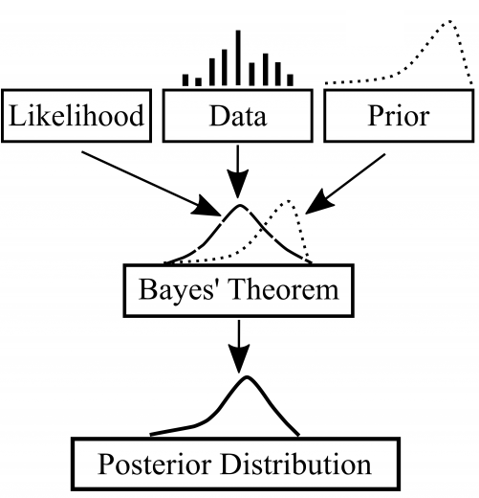

As it is a Bayesian process at each iteration, the distribution of the model’s performance in relation to the hyperparameters used is evaluated and a new probability distribution is generated. With this distribution it is possible to make a more appropriate choice of the set of values that we will use so that our algorithm learns in the best possible way.

**7. Conclusion:**

That's it! We reached the end of our exercise.

Starting with loading the data so far we have done EDA , null values treatment, encoding of categorical columns, feature selection and then model building.

In all of these models our accuracy revolves in the range of 50 to 60%

And there is no such improvement in accuracy score even after hyperparameter tuning.

So the accuracy of our best model is 60% which can be said to be good for this large dataset. This performance could be due to various reasons like: no proper pattern of data, too much data, not enough relevant features.